Fake Ghost Tour

**October 9, 10, 11 and 12 | 6:00, 7:30 and 9:00pm**

$20 per person

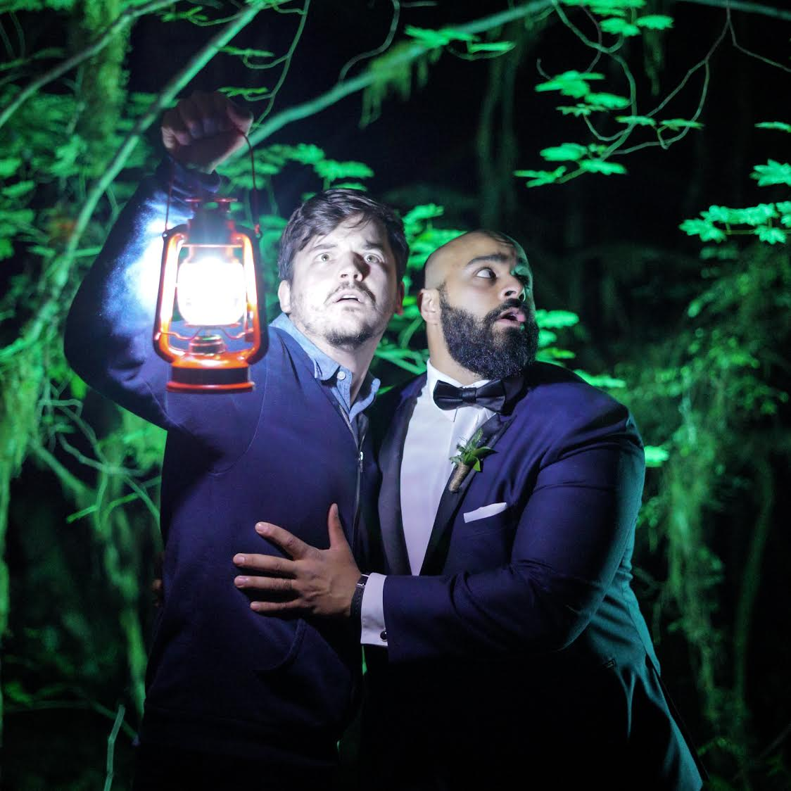

Join amateur ghost hunters and identical twin brothers Abdul and Shawn for a 100% accurate history of the Royal BC Museum.