Subject- Social Studies
Primary grade 3

BC New Curriculum – “Learning about indigenous people nurtures multicultural awareness and respect for diversity.”
First People Principles of Learning- “Learning involves exploration of one’s identity.”

Objectives- Show awareness of First Nations people by discussing First Nations people.

Essential Questions
- Why are stories important to indigenous people?
- Why do elders play a role and important part in the lives of First People?
- What values were significant for local First Peoples?

Vocabulary- canoe, trade, design, paddlers, practical, families

Activity 1

Children can draw canoes, and try to add First Nation designs on their canoe. Also, First Nation community names their canoe that represents their community or who they are.

Activity 2

Indigenous history on transportation- walk, canoe, snow shoe.
First Nation people travelled to trade with other communities. First Nation people travelled from winter to summer homes. In early spring to late fall. They used Canoes for harvest fish, shellfish, seals, sea otters, fruits, tools, and materials for resources, for instance cedar, bark, planks, and logs.

Some canoes were as long as 18 meters. First Nations people often travelled the 1600km round trips south to Victoria from the Northern BC islands and Coast with their large trading fleets of canoes. They were travelling for months at a time, perhaps as far as California.
(First Nation Awareness Education Division. P. 50)

Activity 3

It would be great to students to sort out the traditional roles for each area. (use a Venn Diagram)

Elders- teachings, oral traditions, and storytelling.
Women roles- make weaving baskets, pick berries, harvest berries, clams, clothing preserving food, and make the summer homes. Etc.
Men- hunting, fishing, shelter, longhouse, logs, canoes, and tools, etc.
Children- depending on age, but they would eventually learn from mother or father.

Activity 4

First Nation people still use canoes today, but it’s for different reasons.
- To be close to water and feel a connectedness to nature.
- Tribal Journey and travel with family or canoe family from community to community.
- Canoe races that is held in different communities.
- Train together with Canoe family.
Sports activities involves patience, time and dedication. For people that have one special goal, but have fun trying or succeeding goals is always fun and special.

Children can write what makes a sports family?
- What sport?
- What training is involved?
- What is fun about the sport?
- What is your favorite memory?
- How does it feel to accomplish the goal? Or winning?

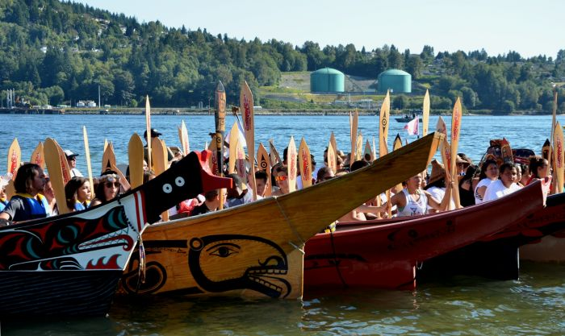
Tribal Journey

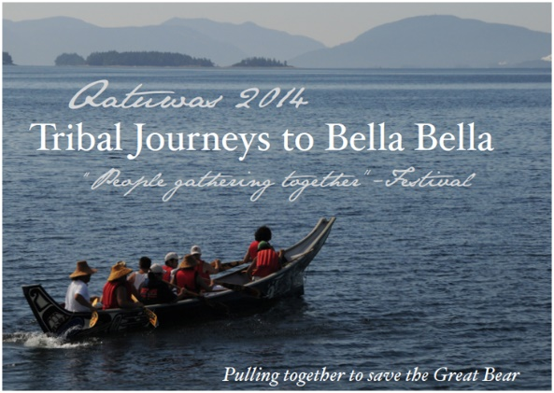

Canoe
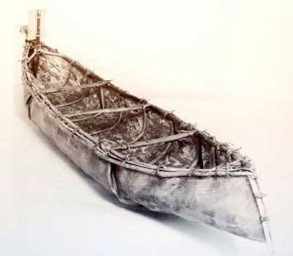

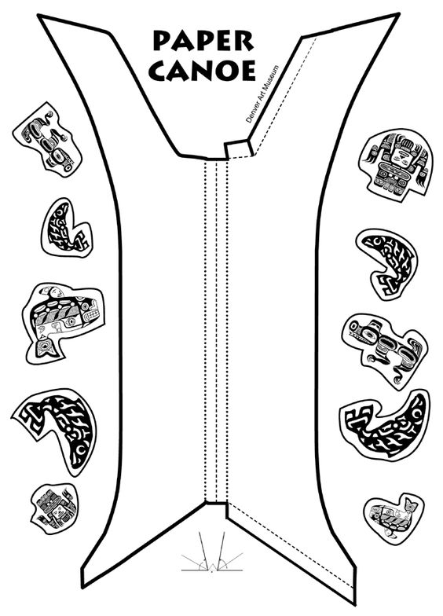
https://www.pinterest.com/pin/456552480944573745/

